Giris Ekrani
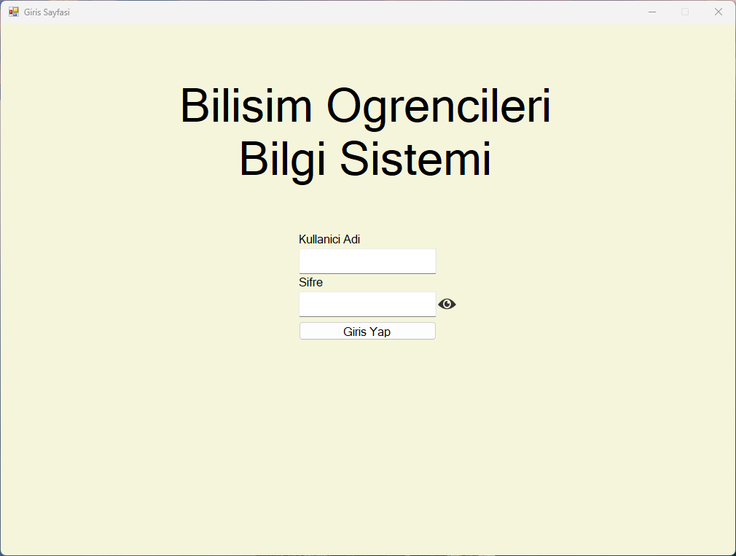
using System;
using System.Collections.Generic;
using System.ComponentModel;
using System.Data;
using System.Data.OleDb;
using System.Drawing;
using System.Linq;
using System.Text;
using System.Threading.Tasks;
using System.Windows.Forms;
using static OgrenciBilgiSistemi.Variables;

namespace OgrenciBilgiSistemi
{
public partial class LogIn : Form
{
public LogIn()
{
InitializeComponent();
}

private void logInBtn_Click(object sender, EventArgs e)
{
Methods.DbConn.DbConnectionOpen("users");

OleDbCommand cmd = new OleDbCommand(
"SELECT * FROM Users WHERE Username=? AND Password=?",
Variables.DbConn.UserConn);

cmd.Parameters.AddWithValue("", usernameEntry.Text);
cmd.Parameters.AddWithValue("", passwordEntry.Text);

OleDbDataReader reader = cmd.ExecuteReader();

if (reader.Read())
{
Variables.Session.tempAccountType = reader["AccountType"].ToString();
Methods.FormSwitching.FormSwitch(this, new MainPage());
}
else
{
MessageBox.Show("Kullanici adi veya sifre yanlis.");
}

reader.Close();

Methods.DbConn.DbConnectionClose("users");
}

bool passIsHidden = true;

private void passShowToggleBtn_Click(object sender, EventArgs e)
{
if (passIsHidden)
{
passwordEntry.UseSystemPasswordChar = false;
passShowToggleBtn.Image = Properties.Resources.eyeclosedpng;
passIsHidden = false;
}
else
{
passwordEntry.UseSystemPasswordChar = true;
passShowToggleBtn.Image = Properties.Resources.eyeopenpng;
passIsHidden = true;
}
}

private void LogIn_Shown(object sender, EventArgs e)
{
Variables.Session.tempAccountType = "";
usernameEntry.Text = String.Empty;
passwordEntry.Text = String.Empty;
}
}
}

